LESSON 5
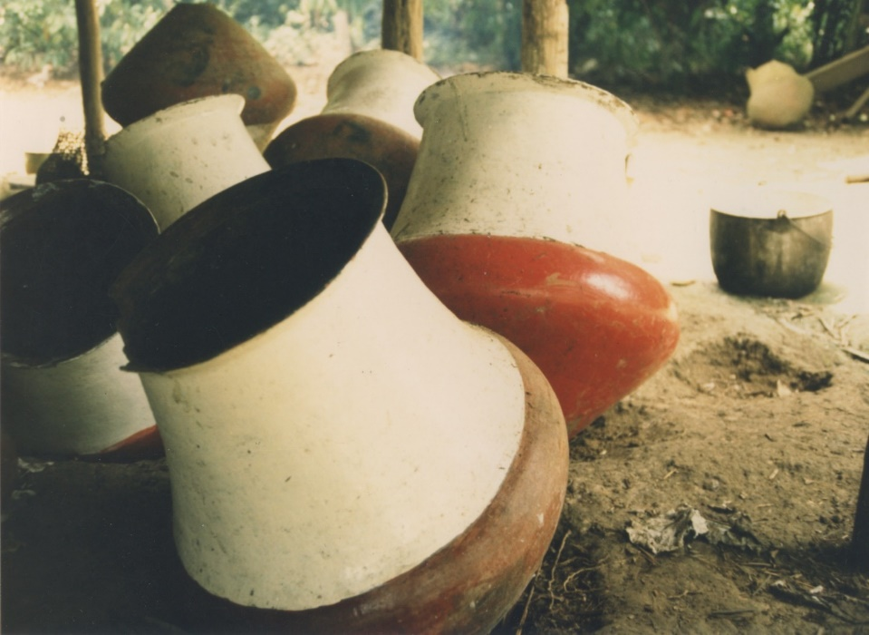
tinaha-guna ‘tinaha-s’

Affirming, negating and evading
More on yes/no questions
The yes/no question suffix –chu may be attached to any type of word in a sentence, whether it is a noun, pronoun, proper name, adjective, adverb, or verb. The decisión over where to put the –chu suffix depends on what a speaker wishes to focus on with that question. For example, by placing –chu on the word for lomocha, the following question focusses upon that word:
Lomochatachu hapingi? ‘Have you caught a lomocha?’
This question focusses on the word for the animal, to emphasize that this particular animal, rather than another was the one caught.
By contrast, another way of asking this question is to focus on the verb instead:
Lomochata hapingichu? ‘Have you caught a lomocha?’
This question, by contrast, focusses on the verb, to emphasize that it was catching rather than just seeing the animal, for example.
Practice 1
Practice varying the focus of each of the following questions by placing –chu onto a different word than the one given for each of the sentences.
Example:
Given sentence: Kay wasiychu puñungi? ‘Is it in this house that you sleep?’
Varying focus sentence: Kay wasiy puñungichu? ‘Is sleeping what you do in this house?’
1.Shigratachu awangi? ‘Is it a shigra that you’ve made?’
2.Canoata awangichu? Is it the case that you made a canoe?’ ‘
3.Hamangaychu puñungichi? ‘Is it in a hammock that you-all sleep?’
4.Lomochatachu mikungichi? ‘Is it a lomocha that you-all eat?’
5.Tinahatachu awangi? ‘Is it a tinaha that you have made?’
6.Kuchatachu rikungi? ‘Is it a lake/pond that you see?’
7.Sindzhita tarabanchu? ‘Is it working that he/she does strongly?’
8.Paychu lomochata hapin? ‘Is he/she the one who has caught a lomocha?’
9.Kanchu hamangata awangi? ‘Are you the one who has made a hammock?’
10.Lomocha yakuy kawsanchu ‘Is it the case that the lomocha lives in water?’ ‘
11.Indillamatachu mikunawn? ‘Is it sloth (meat) that they eat?’
12.Chagramandachu shuwanawn? ‘Is it from the chagra that they steal?’
Negation
Negative statements and negative responses to questions are both formed with a combination of the circumfix mana and the negative suffix –chu. The use of mana /–chu negation involves surrounding whatever element of a sentence is the focus of the negation, with mana preceding it and chu following it. The following example illustrates this circumfix. It is from a traditional story about the bullukuku hawk. This hawk tells little children that one of their parents is not yet asleep, by first making its characteristic sound, namely: bullukuku, and then ‘translates’ its sound into the human utterance ‘He is not yet asleep’. The circumfix mana/-chu surrounds the verb ‘he sleeps’: mana puñunchu as follows:
Bullukuku~kuu~kuu~kuu~kuu, chara mana puñunchu, chara mana puñunchu.
Bullukuku~kuu~kuu~kuu~kuu (which meant) ‘He is not yet asleep; he is not yet asleep’
An audiovisual clip of this sentence may be heard at: http://quechuarealwords.byu.edu/?ideophone=bulyukuku
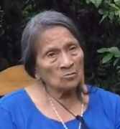
bullukuku riman ‘the bullukuku speaks’
Practice 2
Make negative ‘not yet’ statements out of the following verbs using the model from the traditional story. Vary your person and number.
Example:
Mikuna > chara mana mikundzhu ‘He/she/it has not yet eaten’.
1.hapina ‘to catch’
2.upina ‘to drink’
3.rimana ‘to speak’
4.shamuna ‘to come’
5.likcharina ‘to wake up’
6.tigramuna ‘to return’
7.llukshina ‘to emerge’
8.mingana ‘to have a work party’
9.rikurina ‘to appear’
10.chayana ‘to cook until done’
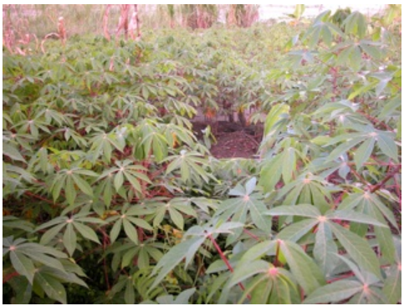
lomo chagra ‘manioc garden
Replying to a yes/no question with a negative statement
When responding negatively to a yes/no question, it is considered polite to supply the questioner with whatever correct information is available. This is a basic cooperative principle of conversational practice that is probably universal. Similarly, a speaker of English will not simply answer a question negatively. He or she will also elaborate the response whenever appropriate. For example, if asked “Have you lived here a long time?”, a polite response would be “No. I’ve only lived here a month.”
The following short dialogues illustrate polite negative responses to yes/no questions. Notice that both the question and the answer have no pronouns. It is quite common for speakers to leave them out of an utterance, which can, nevertheless be understood through context cues.
Question: Lomochatachu hapingi?
Have you caught a lomocha?
Answer: Mana lomochatachu hapini; wagratami hapini.
‘I haven’t caught a lomocha; I’ve caught a tapir’.
The preceding response, while quintessentially correct, is not usually used. The following more abbreviated response is more typical.
Question: Lomochatachu hapingi?
‘Have you caught a lomocha’?
Answer: Mana. Wagratami hapini.
‘No. I’ve caught a tapir’.
Practice 3
Practice your negative responses by using the shorter answer.
Example:
Mikungichu? ‘Have you eaten?
Mana. Upinimi. ‘No. (but) I’ve drunk.’
1. Wasingichu? ‘Are you building a house’? (chagrana ‘to make an agricultural field’)
2. Mikunawnchu? ‘Have they eaten’? (upina ‘to drink’)
3. Tushungichichu? ‘Do you-all dance’? (istudiana ‘to study’)
4. Uktachu shamungi? ‘Do you come quickly’?(alimanda ‘slowly’)
5. Shigratachu awangi? ‘Do you make a bag’? (ashanga ‘basket’)
6. Wasiychu puñungi? ‘Do you sleep in the house’? (chagray ‘in the chagra’)
7. Hamangaychu puñungichi? ‘Do you-all sleep in a hammock’? (kayutuy ‘in the bed’)
8. Chagranawnchu? ‘Are they making a chagra’? (wasina ‘to make a house’)
9. Yanunchu? ‘Does he/she cook’? (tarabana ‘to work’)
10. Lomochatachu mikungichi? ‘Do you-all eat lomocha’? (charapa ‘tortoise’)
11. Tinahatachu awangi? ‘Have you made a tinaja’? (mukaha ‘drinking bowl’)
12. Kuchatachu rikungi? ‘Do you see a lake’? (wasi ‘house’)
13. Wayra shinachu taraban?’Does he/she work like the wind, i.e., very fast’? (alimanda ‘slowly’)
14. Paychu lomochata hapin? ‘Is he/she the one who has caught a lomocha’? (ñuka ‘I’)
15. Kanchu hamangay tiyaringi? ‘Are you the one who sits in the hammock’? (pay ‘he,she,it’)
16. Lomocha yakuychu kawsan? ‘Does the lomocha live in water’? (pambay ‘in the ground’)
Evasion and echo questions
There are a couple of options for answering an information question. Either the information is supplied, or it is not. Quichua speakers may not supply information either because they do not have it, or because they may not feel that a listener is entitled to know the answer to their question. To avoid answering an information question for whatever reason, speakers can simply say mana yachanichu ‘I don’t know’, or, and this is far more common: they answer by first making ‘hm hm’ sounds with the first sound lower and the second higher in pitch. They then echo all or part of the question, often adding the adverb chari ‘perhaps’ to the reply.
Speaker 1: Mayta rin masha Cervantes? ‘Where has brother-in-law Cervantes gone?’
Hm Hm?
Speaker 2: Hm . . .Mayta chari rin?’ Hm ... Where, perhaps, has he gone?’
Such answers may be regarded as performances of uncertainty which illustrate a cultural orientation on the part of Quichua speakers that does not stigmatize a lack of knowledge.
In Quichua speaking culture it is far better to express uncertainty than to speak presumptively without really knowing. When speakers echo another person’s question with the ‘hm hm’ construction, they may be expressing an empathetic stance toward that question, as if to say ‘It’s my question as well, and I wish I could tell you what you want to know, but unfortunately, I can’t.’
Practice 4
Practice answering questions using the hm hm construction.
Example
Mayta rinawn payguna? ‘Where have they gone?’
hm?
Hm Mayta chari rinawn payguna? ‘Hm hm? Where, perhaps, have they gone?’
1. Pita pita lala umata chyu pitin? ‘Who cut the pita lala’s head right off’?
2. Imamandata mana shamunawnchu, payguna? ‘Why do they not come’?
3. Maymandata llukshin lomocha? ‘Where did the lomocha emerge from’?
4. Maymandata paktamun Masha Elario? ‘Where did Brother-in-law Elario arrive from’?
5. Imamandata aswan Kachun Antonia? ‘Why does sister-in-law Antonia make aswa’?
6. Imamandata llullan payba wawa? ‘Why does his/her child lie’?
7. Imamandata mana likcharinchu kanba hachi? ‘Why does your uncle not wake up’?
8. Imamandata wakan, kanba wawa? ‘Why does your child cry’?
9. Imamandata sakirin payba mikya? ‘Why does your aunt remain’?
10. Maymandata shamun apa yaya? ‘Where does grandfather come from’?
The plural suffixes –guna/-una
The plural suffixes –guna, used in PQ, and –una, used by NQ speakers are used with several categories of words. Most often they pluralize nouns:
charapa charapaguna
wawa wawaguna
ñaña ñañaguna

Suffixation with –guna (PQ) or –una (NQ) may have the effect of changing an adjective into a noun:
ichilla ‘little’ ichillaguna ‘the little ones’
kuska ‘straight’ kuskaguna ‘the straight ones’
puka ‘red’ pukaguna ‘the red ones’

-Guna is also used to pluralize demonstrative pronouns:
kay ‘this’ kayguna ‘these’
chay ‘that’ chayguna ‘those’
To make phrasal constructions plural, -guna or –una is suffixed only to the head of the phrase, rather than to modifiers. For example, in a phrase consisting of a demonstrative and noun, only the noun is pluralized:
chay wawa ‘that child’ > chay wawa-guna (PQ) chay wawa-una (NQ)
Practice 5
Practice making plural forms for the following phrases.
Example:
Ñukanchi wasi ‘our house’ > Ñukanchi wasiguna or Ñukanchi wasiuna
1. ñukanchi ñana ‘our sister’
2. chi sacha wagra ‘that tapir’
3. kay wagra ‘this cow’
4. ñuka hachi ‘my uncle’
5. chi mana ali wawa ‘that not well-behaving child’
6. kay ichilla ‘this little one’
7. kay ali ‘this good (one)’
8. chi sindzhi ‘that strong one’
9. kay chunda ruya ‘this peach palm tree’
10. chi hatun kucha ‘that big pond’
11. chi mana kuska ñambi ‘that not straight path’
12. kay tullu runa ‘this boney person’
-Guna and -una can also pluralize proper names to designate a group of people. For example, speakers frequently take the name of one person among a group and add a plural to designate the group as a whole:
Faustoguna shamunawn. ‘Fausto and the people with him have come.’
Practice 6
Practice turning the following singular sentences into plural sentences. Pluralize the subject and then make the verb agree with that subject in each sentence.
Example:
Cervantes shamun > Cervantesguna shamunawn.
1. Wawa wakan. ‘The child cries’.
2. Kan shamungi ‘You come’.
3. Pay shuwan. ‘He/she/it steals’.
4. Ñuka apa yaya taraban ‘My grandfather works’.
5. Leopoldo bagrita hapin. ‘Leopoldo catches a catfish’.
6. Kanoa yakuy shayarin. ‘The canoe stands in the water’.
7. Pay aychata mana kasanchu ‘He doesn’t hunt for meat’.
8. Ñuka wawki pugllan. ‘My brother plays’.
9. Ñuka masha shamun. ‘My brother-in-law comes’.
10. Payba mikya paktamun. His/her aunt arrives’.
11. Ñuka ruku yaya chagray taraban. ‘My grandfather works in the field’.
12. Wawa kayutuy sirin ‘The baby lies in bed’.
13. Ñuka turi sachamanda tigramun. ‘My brother returns from the forest’.
14. Ñuka pani tinahata awan. ‘My sister makes a tinaha’.
15. Pay tukuta mikun. ‘He/she eats grubs’.
16. Pay kuska nambita apanakun. ‘He/she follows the straight path’.
17. Leopoldo mana ali ñambita apanakun. ‘Leopoldo follows the not good path’.
18. Chunda ruya pukun. ‘The chunda tree ripens’.
Culture focus: traditional festival: hista
Study the photograph below, taken from a traditional festival or hista that took place in Puka Yaku, a small settlement along the Bobonaza River. The festival is celebrated over several days. It involves drinking massive quantities of aswa, which is the staff of life for many Amazonian Quichua people. Women spend weeks preparing the aswa, which is made from cooked manioc tubers that have been mashed, masticated, and allowed to ferment for a couple of days. The result is a mildly fermented substance with a mashed potato-like consistency that is mixed with water and drunk. Women also make new drinking bowls or ‘mukahas’ for this celebration, many of which are ceremonially smashed after being drunk from. Festival etiquette requires that anyone who is offered aswa must accept it and drink the entire quantity from the mukaha. Not doing so gives the offerer license to pour the aswa all over the person who did not drink it.
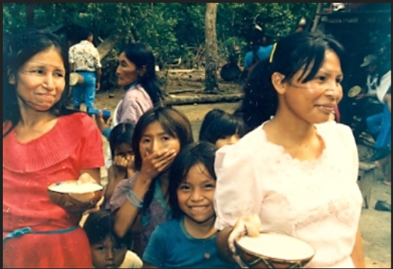
hista ‘festival’
Written Exercise
Using what you have learned in Lessons 4 and 5, answer the following questions based on what you think is happening in the photograph. Some questions will need to be answered by supplying information. Others will be answered as affirmations using –mi or negations using -chu. There may also be unanswerable questions.
1.Imata rikungi?
2.Imata ranawn warmiguna?
3. Wawagunaga? Imata ranawn?
4.Warmiguna puñunawnchu?
5. Wawaguna istudianawnchu?
6.Pita chari upichinawn, warmiguna?
7.Imata charinawn warmiguna?
8.Upingichu aswata?
9.Kamba yaya aswatachu upin?
10.Kamba mama mukahata awanchu?

