Part 1
Self and OtherIn this section we introduce fundamentally important skills for orienting oneself in relation to others within the Quichua speaking world of runa shimi. We introduce basic social moves such as greetings and leave-takings and the asking of several different types of questions for figuring things out in a new language world. You will learn how to form the simplest complete sentences, along with the most basic grammatical distinctions such as that between subjects and direct objects, and between statements made from a speaker’s perspective and those made from the perspective of an ‘other’. Pronouns and kinship terms for addressing the most significant others in your life are introduced, including members of one’s nuclear family, kin terms for relatives by marriage, and terms for those you might choose to include in your family. Body part terminology for human selves and nonhuman others, impersonal verbs involving inner processes said to happen to one, concepts of possession, and numbers are all introduced. Suffixes for expressing thoughts, feelings, and processes, as well as instrumentality and accompaniment are taught. The final unit of this section introduces suffixes for distinguishing between togetherness and separateness.
LESSON 1
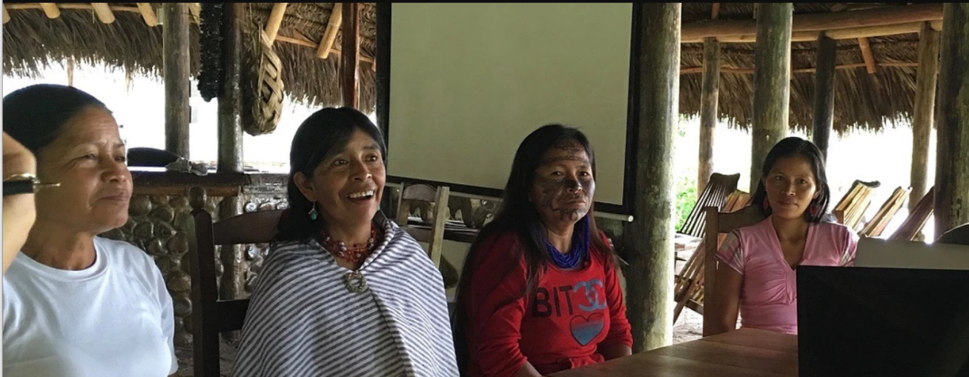
asina ‘to laugh, smile’
The most basic verbal interactions:greetings as yes/no questions
Among Quichua speaking people there is a high value placed on demonstrating one’s sociability toward others in everyday life. Humor is a key ingredient for sociable behavior and more will be said about this in lessons to come. More generally, there is a principle of conviviality which requires people to adopt a pleasant and friendly demeanor in interactions with others.
Not surprisingly, therefore, greeting behavior is important, even though Quichua does not have dedicated words to greet others, such as the English forms ‘Hello’ and ‘Hi’ or the Spanish forms ‘Ola’ or Buenos dias’, etc. Instead, people greet each other quite often by asking a question such as ‘Have you come’?, or ‘Are you living’? Such questions are similar to ‘How are you?’, except that they barely count as questions, since the answers are so obvious. They are quite important, nevertheless, for displaying your sociable self to others. We begin therefore with the most fundamental form of social behavior—the yes/no question.
When asking a yes/no question, the interrogative suffix -chu is added to the word which is the focus of the question. For example:
Conversation Model 1
Kawsangi-chu? ‘Are you alive’?
The affirmative response then uses the -mi suffix to respond:
Kawsani-mi ‘I’m alive’
Please note that for Quichua verbs, stress is usually placed on the next to last syllable which is boldfaced below:
Kawsangi-chu? ‘Are you alive’?
Kawsani-mi ‘I’m alive’
Without the –chu or –mi suffixes, however, the verbs’ stress would be:
Kawsani ‘I’m alive’
Kawsangi ‘you are alive’
As this yes/no question format is important generally for many types of conversations beyond simple greetings, it will be helpful to practice it below.
Practice 1
Practice the yes/no question of conversation model 1 using –chu on the first verb form and –mi on the second:
Example:
Waytangi ‘you swim’/ waytani ‘I swim’
Waytangichu? ‘Do you swim?’ Waytanimi! ‘I do swim’
Now, based on the example above, use the following sets of verbs to ask and answer yes/no questions:
1.Paktamungi ‘you arrive’/ paktamuni ‘I arrive’
2.Mikungi ‘you eat’/ mikuni ‘I eat’
3.Puringi ‘you walk’/ purini ‘I walk’
4.Tiyangi ‘you hang out’/ tiyani ‘I hang out’
5.Yanungi ‘you cook’/ yanuni ‘I cook’
6.Tarabangi ‘you work’/ tarabani ‘I work’
7.Aswangi ‘you make aswa’/ aswani ‘I make aswa’
8.Wasingi ‘you make a house / ‘wasini ‘I make a house’
9.Chagrangi ‘you make an agricultural field/ chagrani ‘I make an agricultural field’
10.Puñungi ‘you sleep’/ puñuni ‘I sleep’
More complex yes/no questions
The suffixes –chu and –mi are recognized by linguists as special, and called ‘enclitics’, because they can be attached to any type of word, whether a verb, noun, pronoun, or adverb. In the next exercise you will practice adding adverbs to basic sentences, and then add question and answer suffixes to these as well.
Adverbs in English have a low status, especially among teachers of creative writing who often tell their students to avoid using them. In Quichua, however, adverbs are a very important, widely used class of words. They typically occur before the verb they modify, but may occur after as well. In the example below, a speaker asks a yes/no question by focusing on the adverb alilla ‘well’. Note that unlike verbs, which shift stress with the addition of the suffixes –mi and –chu, adverbs (and also adjectives) retain their original penultimate (next to last syllable) stress even after these suffixes are added:
Conversation Model 2:
Alilla-chu paktamungi?

‘Have you arrived well?’ (That is, Did you have a good trip?”)

Nda. Alillami paktamuni.

‘Yes. I’ve arrived well.’(That is, I’ve had a good trip.’)

Practice 2

Reproduce the preceding dialogue using the following adverbs and verbs.
Example:
alimanda ‘slowly’ tarabangi ‘you work’
Alimandachu tarabangi? Nda/Ari. Alimandami tarabani.

alimanda ‘slowly’ istudiangi ‘you study’
ukta ‘fast’ mikungi ‘you eat’
alilla ‘well’ tiyangi ‘you dwell in a place, you hang out’ iridza ‘ugly, bad’ muskungi ‘you dream’
sapalla ‘alone’ kawsangi ‘you live’
wayra shina ‘very fast, lit: ‘like the wind’ yanungi ‘you cook’
wayra shina killkangi ‘you write’
wayra shina rimangi ‘you speak’
sindzhita ‘strongly’ waytangi ‘you swim’
sindzhita puringi ‘you walk, trek, or travel’
chunlla ‘quietly’ tiyangi ‘you be located ‘
chunlla puñungi ‘you sleep’
waka waka ‘crying and crying’ puñungi ‘you sleep’
kushilla ‘happily’ asingi ‘you laugh’
Culture Focus: the sounds of laughter
Runa people place a lot of importance on sociability and cheerfulness even under difficult situations. Laughing in the face of danger or despair is an ability that people admire. Laughter in general, however, is positively valued and people enjoy reports about laughter, as well as talking about the sounds and qualities of laughter. Interestingly, Runa peoples’ representations of laughter are not much different from an English speaking person’s. Laughter in Quichua is often expressed by the syllable ha, which is usually repeated multiple times.
Go to the following link: http://quechuarealwords.byu.edu/?ideophone=ha
and watch video 2 where a woman uses ha to describe the laughing sounds made by people who are gathered together to share food. She contrasts these happy social sounds to the melancholy sound of a bird called the kukuli bird, who is said by the happy people to be sad because of being alone.
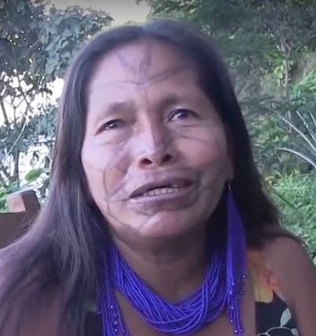
kukuli ‘sad cry of bird’
A variant of ha, ha hay, is sometimes used to describe extremely celebratory laughter occurring at festive occasions. Go to video 1 at the following link: http://quechuarealwords.byu.edu/?ideophone=hahay and listen to a representation, from a traditional flood narrative, of celebratory laughter by intoxicated people who will not heed warnings about an impending flood.
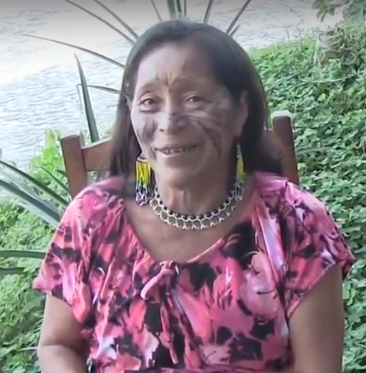
ha hay ‘celebratory laughter’
Ending a social interaction
Just as Quichua has no dedicated greeting words such as ‘hello’, it also has no dedicated word such as ‘goodbye’ to end a social interaction. Speakers will simply say kayagama ‘until tomorrow’, or rinimi ‘I’m going’, or rishalla ‘I will just go’.
Speakers who are being left will sometimes anticipate another person’s departure by observing their preparatory movements or by inferring their departure from the conversational context. This is what happens in the following conversational model between two people who are related to each other by compadrazgo ties:
Conversation Model 3:
Riungichu kumpari? ‘Are you going compadre?’
Ari. Riunimi kumari, kayagama ‘Yes, I’m going comadre. Until next time’

Translation exercise
Listen to an actual example of a response to leave-taking by going to the following link: https://www.youtube.com/watch?v=zjzg-iGXWtA to watch and listen to Luisa Cadena who notices North American students leaving for an extended hike in the forest. Notice how she says good-bye to them using informal Spanish chao, as well as with Quichua (2:25-2:31) words. Identify and translate the Quichua words.
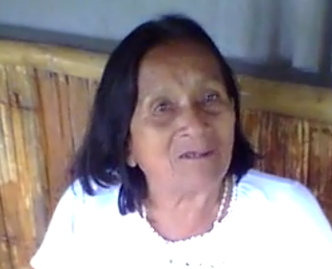
chao and other greeting words

Culture Focus: Forest resources: the piwi plant and pottery
Regarding the comings and goings of Amazonian peoples, it is interesting to note the reference points for people as they travel. Fast growing second growth trees often dominate the skyline in previously deforested areas of the upper Amazon. People from that part of the world know they are home when they see the unmistakeable branching of Pollalesta discolor, a member of the Asteraceae or aster family of flowering plants, against the evening sky. Piwi ,(pictured below left), as it is referred to by Runa, is particularly valued by women as a wood for the firing of mukaha a type of ceramic polychrome drinking bowl pictured below.

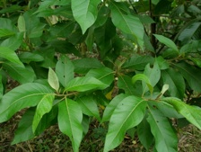
Piwi plant

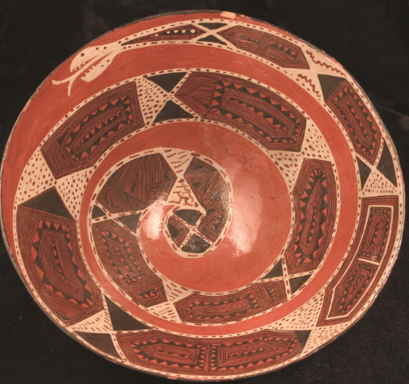
mukaha interior view, anaconda pattern

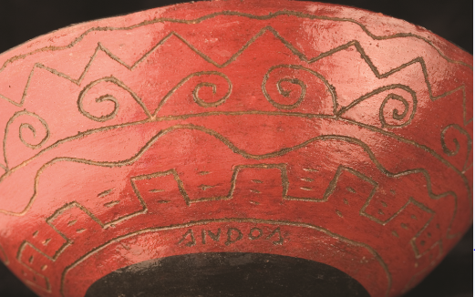
mukaha exterior view with incising

